**CPMC Go Live Communications: Roles and Responsibilities/Work Flows**

**Oct. 30, 2013**

**Guiding Principles/Parameters**

* Timely, simple and short messaging to end users
* Employ multiple channels to maximize reach to end users – both electronic and face-to-face methods
* Target messaging as appropriate to maximize relevance
* Physician Engagement leadership to manage communications to physicians (with a few pre-approved exceptions).
* Quality Champion leads to manage electronic communications to Quality Champions, per Champions request

**Four Communication Buckets**

* External (media, elected officials)
* Command & Control Center Communications
* Mass Communications to employees and physicians
* Tip Sheet, System Updates and Safety Alerts for all internal audiences or targeted audiences

**Key Communicators**

* Mather
* Leadership (Sutter Health EHR, CPMC and WBR)
* CPMC Command & Control Centers
* WBR EHR Communications Team
* Physician Engagement Team
* Quality Champions
* Zone Coordinators
* Domain Group leaders
* Daily Management System huddle coordinators
* CPMC Directors, Managers and Supervisors
* CPMC Media Relations Team

**Key Deliverables (timing, responsibilities, workflows)**

EHR Go Live Announcement

*Phase One (asap after Go Live)*

* Everbridge announcement to Dept telephones (Sforzo)
* Email to All CPMC Recipients (employees and physicians) (Nguyen)
* Screensaver (Nguyen)
* Portal Update (Nguyen)

*Phase Two*:

* Physician Engagement leadership cascades to other physicians/Physician SuperUsers
* Padavano issues systemwide email (est 1 hour post Go Live)
* Word of mouth at unit level (Zone Coordinators, Quality Champions, etc)

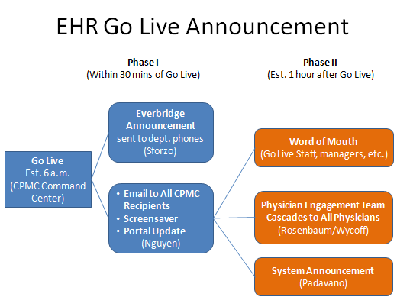

_______________________________________________________________________________

*EHR Go Live News* (electronic newsletter)_

* Begins Sunday, Nov. 3; reports on progress from the previous day.
* Issued daily for minimum of one week.
* Drafted by T Nguyen based on information from 4pm Leadership Meeting; Graham as backup
* Topics include: general messaging, housewide trends, KPIs, other general updates
* Approved by Padavano, Isenberg, Calhan, Vercruysse and/or Barr

Distribution:

* Nguyen sends via email to All CPMC Employees (not physicians) and to EHR Implementation Team
* Nguyen sends Word version to Wycoff and Rosenbaum, who review and edit as appropriate for relevance to physician audience; they distribute to physicians
* Nguyen uploads to portal
* Padavano forwards to Sutter Health leadership
* QCs, Zone Coordinators, Directors and Managers to cover in Daily Huddles

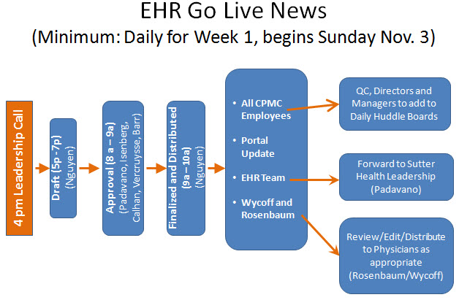

___________________________________________________________________________________

Tip Sheets, System Updates and Safety Alerts*

*These documents are generally issued by Mather at 12 noon and 6:30 pm – daily; if there are none to be issued, Mather will indicate such at these times.*

*Face-to-Face distribution:*

* Mather Project Coordinators and Zone Huddle Leaders will share with Zone Coordinators at their 2/x daily Zone Coordinator Huddles. Quality Champions and Domain leads who are able will be asked to attend the 1pm ZC Huddles.
* Zone Coordinators will share information with Quality Champions when QCs begin their shifts and will also place on the Daily Management Huddle boards.
* Quality Champions will share with Domain Groups at the 10 am Domain Group Huddle.
* Topics will be covered by Quality Champions, Zone Coordinators at the Daily Huddles for staff.
* Physician distribution will be through the Physician Engagement Team (robust plan in place)

*Email Distribution:*

* Patient Safety /General Patient Alert and System Update notifications will be sent directly from Mather to CPMC Directors, Managers and Supervisors (no cc’s).
* Tip Sheets will not be sent to Directors, Managers and Supervisors; rather, they will be encouraged to regularly check the EHR Portal Tip Sheet Index for updates.

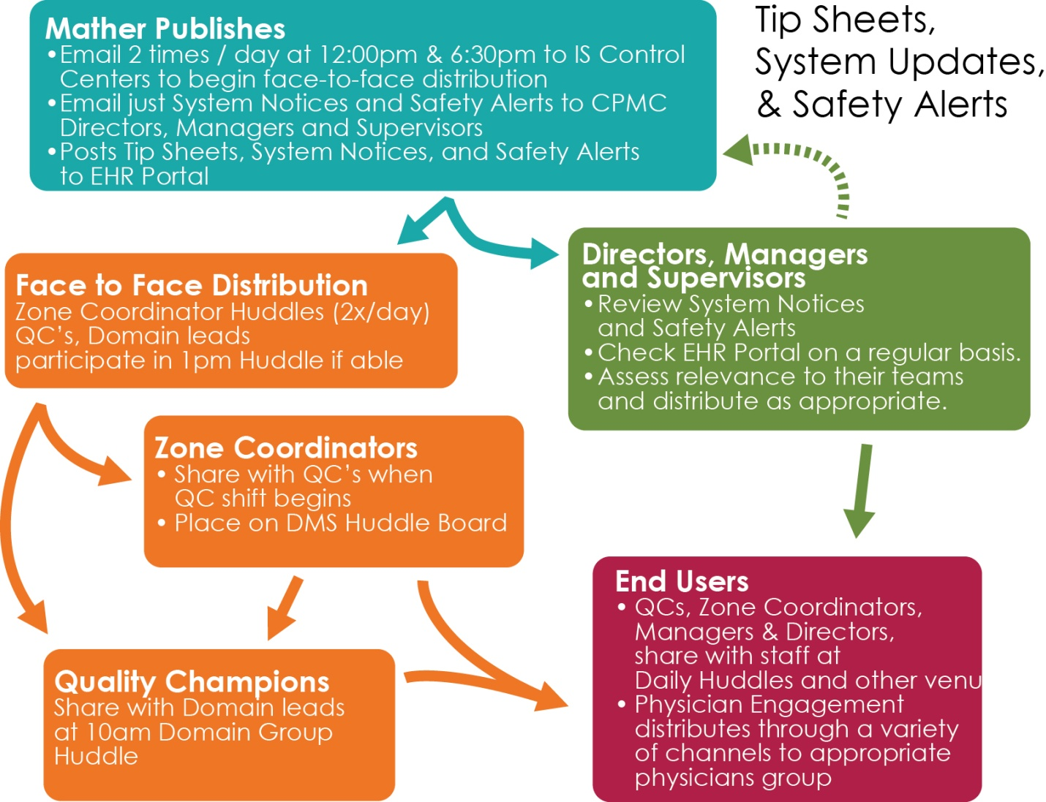

*Further team discussion will be held in Dec. 2013 to hardwire distribution of these communications when Zone Coordinators, others are no longer in place.

_____________________________________________________________________________________

Media

Media is reactive only. Calls will be received by Dean Fryer, CPMC Media Relations Mgr, or Barbara Dunn, WBR Communications Director.

If call received, Fryer/Dunn will contact Graham or Nguyen, who will assess overall Go Live status/any major issues that might be relevant and inform Fryer/Dunn appropriately. Graham or Nguyen will inform CPMC Command Center leaders of any media inquiries.

If major patient care issues, Fryer/Dunn will consult with HR and/or Legal re messaging

Fryer as media spokesperson.

Note that a robust Media Plan, including messages and Q/A, is in place

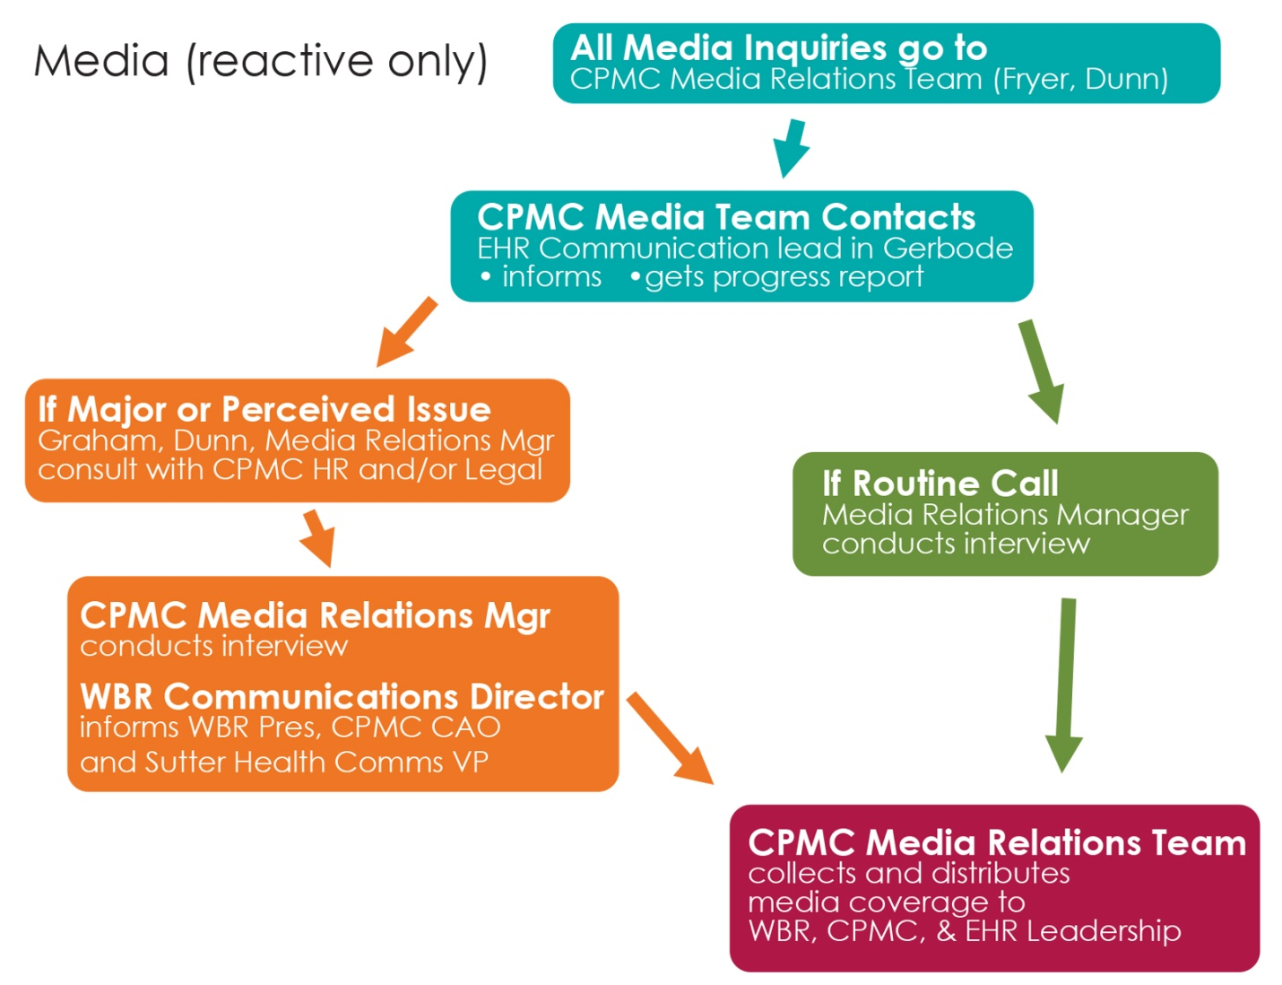

_____________________________________________________________________________________

Other

Mike Cohill to proactively communicate to WBR Board post Go Live (Dunn) and to elected officials as indicated (Dunn)

*Ad hoc* needs to be triaged and potentially filled by EHR Communications Team (Nguyen and Graham, who will be on call 24/7 for November).